Name

Mathematics Stage 4
Pythagoras’ Theorem

Book 1 | Identify and define Pythagoras’ theorem  Examine problems involving Pythagoras’ theorem | Version: 260707  Feedback:  https://MrDingMaths.com
Contents
Syllabus Content 2
Learning Intention Error! Bookmark not defined.

Syllabus Content
MA4-PYT-C-01 applies Pythagoras’ theorem to solve problems in various contexts
Identify and define Pythagoras’ theorem
- Identify and describe the hypotenuse as the side opposite the right angle and the longest side in any right-angled triangle
- Establish the relationship between the lengths of the sides of a right-angled triangle
- Use the relationship to record and define Pythagoras’ theorem both algebraically and in words
Examine problems involving Pythagoras’ theorem
- Justify whether a set of 3 integers is a Pythagorean triad
- Apply Pythagoras’ theorem to find the unknown length of a side in a right-angled triangle, giving answers in an exact form or as decimal approximations
- Apply the converse of Pythagoras’ theorem to establish whether a triangle is right angled
- Solve practical problems involving Pythagoras’ theorem before exploring a variety of related problems

The Hypotenuse

- Right-Angled Triangles and Hypotenuse
A triangle with a 90-degree angle is a right-angled triangle.
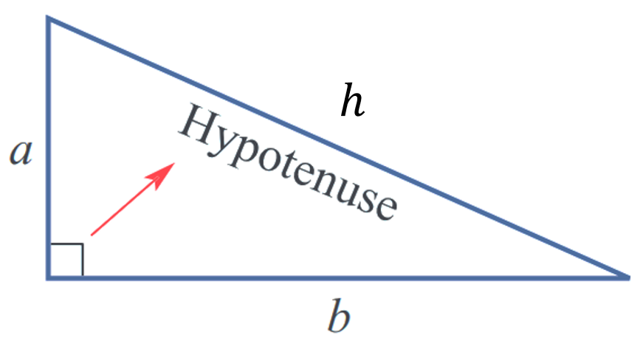
In a right-angled triangle, we call the longest side opposite the right-angle the hypotenuse.

- Identify hypotenuse of a right-angled triangle
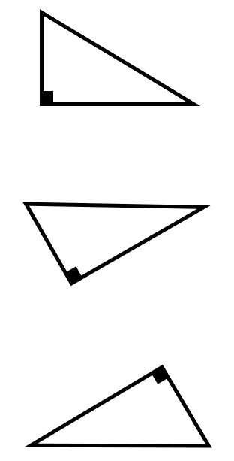
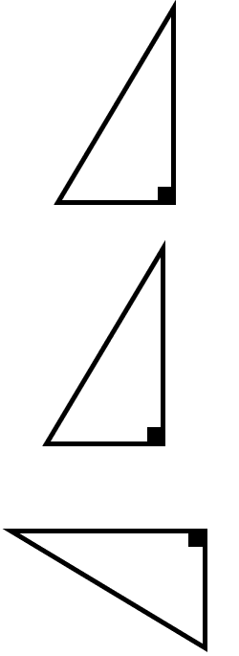
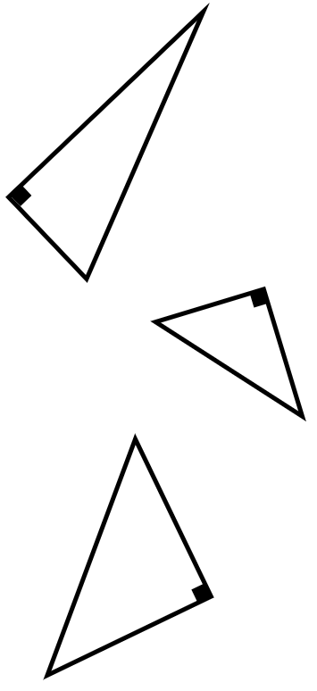
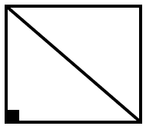
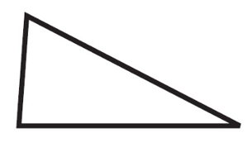
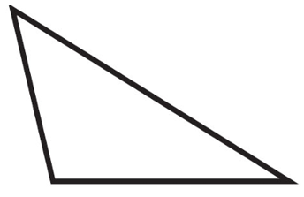
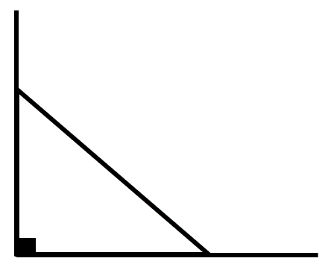

- Key Ideas
- If a triangle has a $90°$ angle, then it is ……………-………………
- In a diagram, a right-angle is shown using a …………… symbol.
- If a triangle is right-angled, then we call the ……………… side …………… the right angle the hypotenuse.

Foundation
- Identify the hypotenuse of these triangles.
5 | 17 | 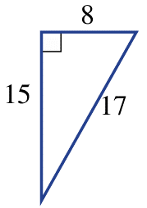  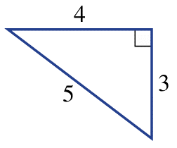  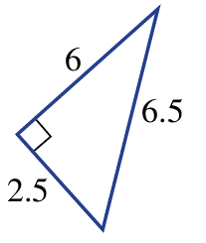  6.5
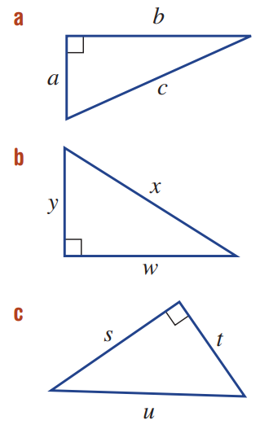  $$c$$ | $$x$$ | $$u$$

- Assuming these triangles are right-angled, show on the diagram where right angle would be.
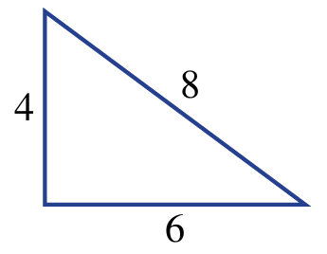  Between 4 and 6 | 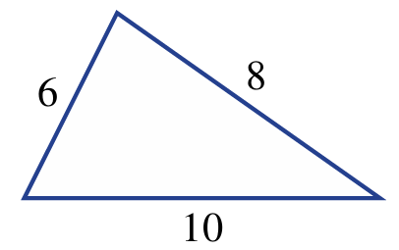  Between 6 and 8 | 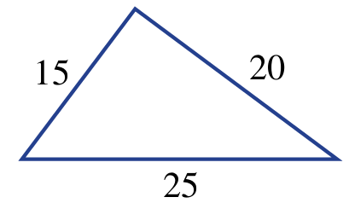  Between 15 and 20

- A ladder is leaning against a wall.
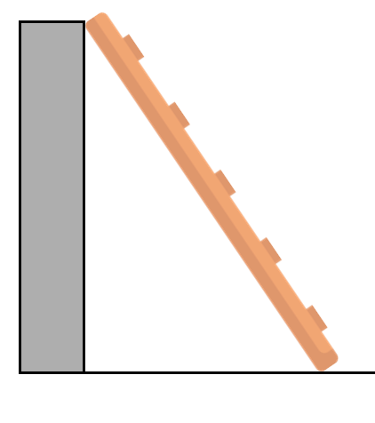
Which statement (A, B, or C) describes the hypotenuse?
- The horizontal distance between the base of the ladder and the wall.
- The vertical distance between the floor and the top of the ladder.
- The length of the ladder.

C

Pythagoras’ Theorem

- Review
- Square numbers
- $3^{2}$ | - $5^{2}$ | - ${1.2}^{2}$
- ${0.8}^{2}$ | - $4^{2}+3^{2}$ | - $5^{2}+{12}^{2}$

- Investigation Pythagoras’ Theorem
Each side of these triangles has been measured.
2
4 cm
7.5 cm
8.5 cm
1
3 cm
4 cm
5 cm

3
2.5 cm
6.5 cm
6 cm

4
8 cm
5.4 cm
7.5 cm

Complete the table.
 | Shorter sides |  | Longest Side
Triangle | $$a$$ | $$b$$ | $$c$$ | $$a^{2}$$ | $$b^{2}$$ | $$a^{2}+b^{2}$$ | $$c^{2}$$
1
2
3
4

- Pythagoras’ Theorem
If a triangle is right-angled, then its side lengths satisfy the equation:

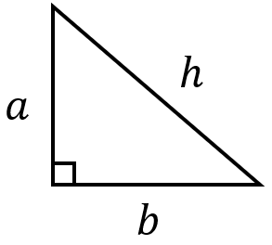

shorter sides

$a^{2}+b^{2}=c^{2}$
$$3^{2}+4^{2}=5^{2}$$
$$a^{2}+b^{2}=h^{2}$$
$$9+16=25$$
$$+$$
$$=$$

hypotenuse

- Pythagoras’ theorem: https://www.geogebra.org/m/bt27dew8
- Pythagoras’ theorem visual proof: https://www.geogebra.org/m/t3zvxd9u

- Write Pythagoras’ theorem for a triangle
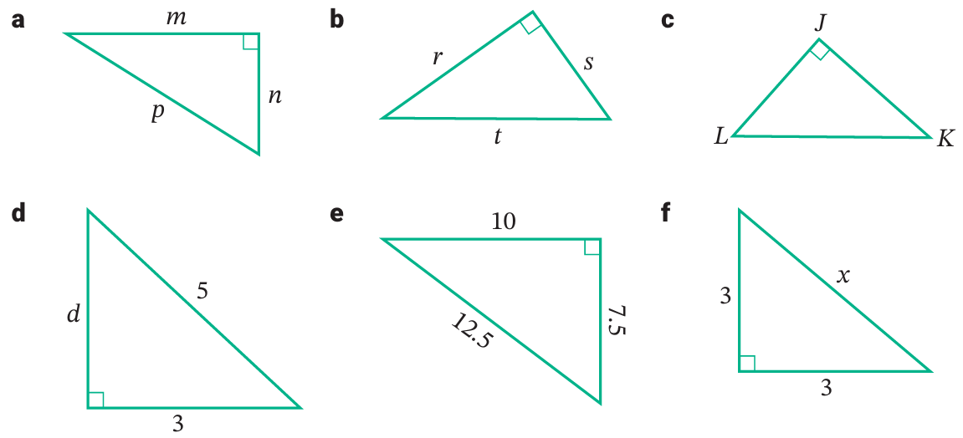

Foundation
- Write an equation describing the relationship between the sides of these right-angled triangles.
$$side^{2}+side^{2}=hypotenuse^{2}$$
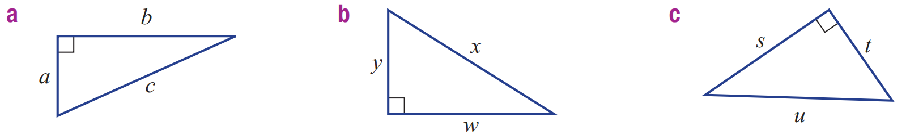  ………² + ………² $=$ ………²  $$a^{2}+b^{2}=c^{2}$$ | $$w^{2}+y^{2}=x^{2}$$ | $$s^{2}+t^{2}=u^{2}$$
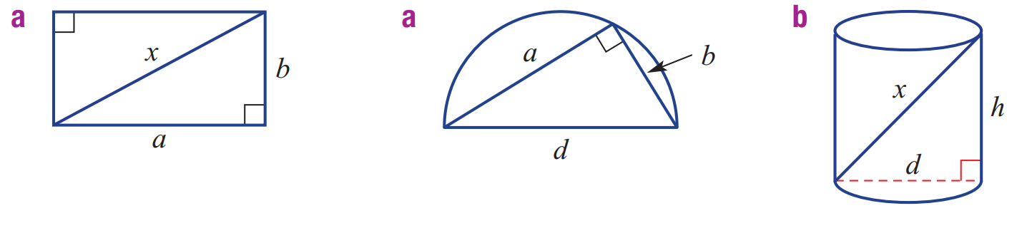  $$a^{2}+b^{2}=x^{2}$$ | $$a^{2}+b^{2}=d^{2}$$ | $$d^{2}+h^{2}=x^{2}$$

- Check that $a^{2}+b^{2}=h^{2}$ for all these right-angled triangles.
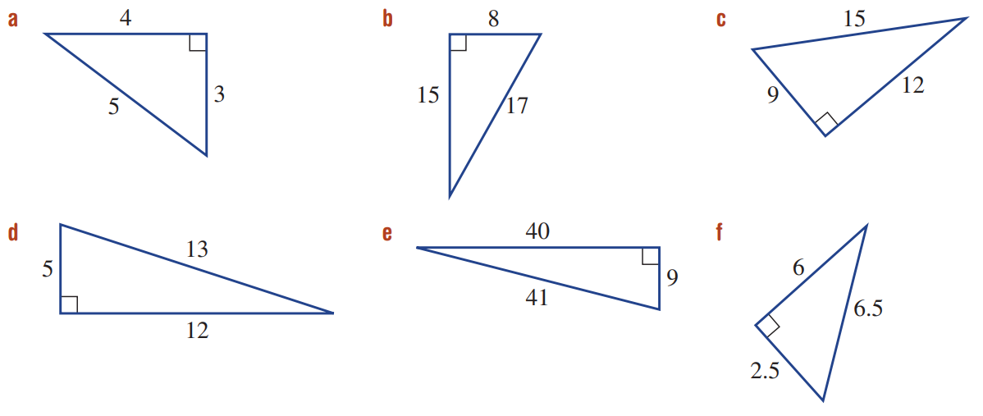
  $a^{2}+b^{2}=$ 3² + 4²  $=$…… + ……  $=$…… | $h^{2}=$ 5²  $=$ ……
  $a^{2}+b^{2}=$…… + ……  $=$…… + ……  $=$…… | $h^{2}=$ ……  $=$ ……
  $a^{2}+b^{2}=$…… + ……  $=$…… + ……  $=$…… | $h^{2}=$ ……  $=$ ……
  $a^{2}+b^{2}=$…… + ……  $=$…… + ……  $=$…… | $h^{2}=$ ……  $=$ ……

Prove a Triangle is Right-Angled

- Proving a Triangle is Right-Angled
A triangle is right-angled if its side lengths satisfy $a^{2}+b^{2}=h^{2}$.
If the triangle’s side lengths do not satisfy the equation $a^{2}+b^{2}=h^{2}$, then it’s not right-angled.

- Example Prove whether a triangle is right-angled using Pythagoras’ theorem
Determine whether this triangle is right-angled.
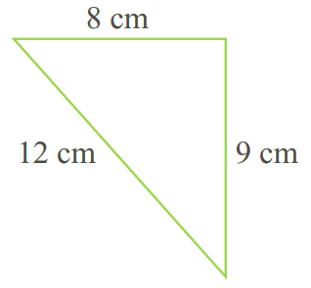
$a^{2}+b^{2}=$ $8^{2}+9^{2}$  $=64+81$  $=145$ | $h^{2}={12}^{2}$  $=144$
$a^{2}+b^{2}≠h^{2}$
So, this is not a right-angled triangle.

- Guided Practice
Determine whether these triangles are right-angled.
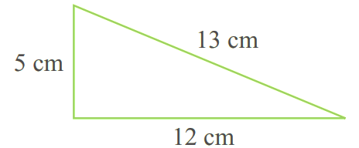 | 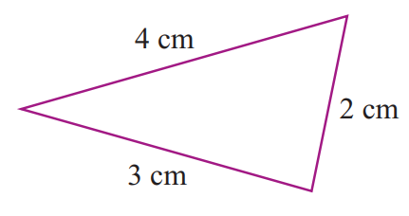
  $a^{2}+b^{2}=$…… + ……  $=$…… + ……  $=$…… | $h^{2}=$ ……  $=$ ……

- Key Ideas
- The three sides of every right-angled triangle satisfies the Pythagoras’ theorem,
…… + …… = ……
- If a triangle does not satisfy Pythagoras’ theorem, then it is ………………………………

Foundation
- These diagrams are not drawn to scale. Prove that:
- This triangle is right-angled. | 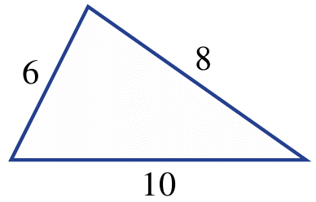  - This triangle is NOT right-angled.  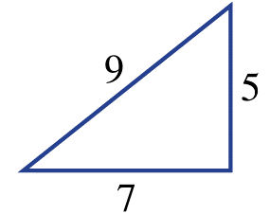
  $a^{2}+b^{2}=$…… + ……  $=$…… + ……  $=$…… | $h^{2}=$ ……  $=$ ……
  $$6^{2}+8^{2}=100$$
  $${10}^{2}=100$$
  $$∴right angled, a^{2}+b^{2}=h^{2}$$
  $a^{2}+b^{2}=$…… + ……  $=$…… + ……  $=$…… | $h^{2}=$ ……  $=$ ……
  $$7^{2}+5^{2}=74$$
  $$9^{2}=81$$
  $$∴not right angled, a^{2}+b^{2}≠h^{2}$$

- Decide whether these shaded triangles are right angled.
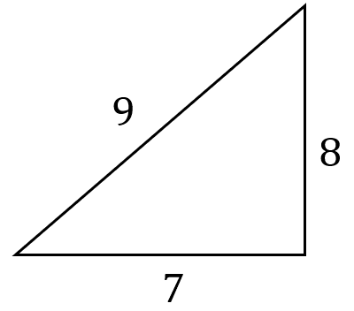 | 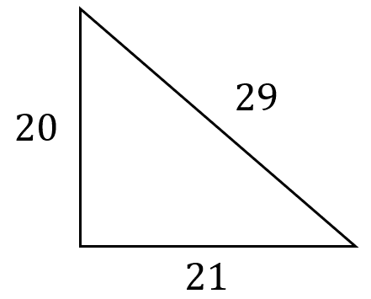
  $$7^{2}+8^{2}=113$$ | $$9^{2}=81$$
  $$∴not right angled, a^{2}+b^{2}≠h^{2}$$
  $${20}^{2}+{21}^{2}=841$$ | $${29}^{2}=841$$
  $$∴right angled, a^{2}+b^{2}=h^{2}$$
 | 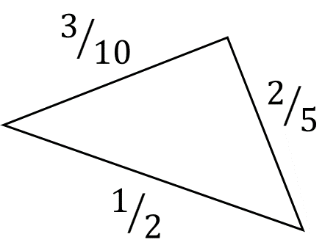  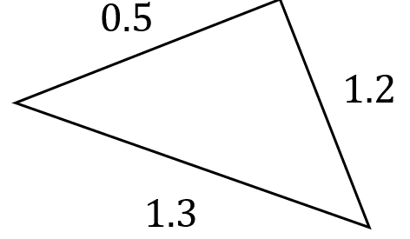
  $${0.5}^{2}+{1.2}^{2}=1.69$$ | $${1.3}^{2}=1.69$$
  $$∴right angled, a^{2}+b^{2}=h^{2}$$
  $${\left(\frac{3}{10}\right)}^{2}+{\left(\frac{2}{5}\right)}^{2}=\frac{1}{4}$$ | $${\left(\frac{1}{2}\right)}^{2}=\frac{1}{4}$$
  $$∴right angled, a^{2}+b^{2}=h^{2}$$

Pythagorean Triads

- Pythagorean Triads
If three whole numbers $\left(a,b,c\right)$ satisfy $a^{2}+b^{2}=c^{2}$, where $c$ is the largest number,
then they are a Pythagorean triad.

- Example Determine whether 3 numbers are a Pythagorean triad
Is 13, 12, 5 a Pythagorean triad?  $a=5$, $b=12, c=13$  $a^{2}+b^{2}=5^{2}+{12}^{2}$  $=169$  $c^{2}={13}^{2}$  $=169$  Yes. 13, 12, 5 is a Pythagorean triad. | What is a Pythagorean triad?  A Pythagorean triad is ………… numbers that satisfy ………………’ Theorem  What should you let $c$ be in $a^{2}+b^{2}=c^{2}$?  $c$ should always be the ………… number in the list.

- Guided Practice
Test whether these three numbers are Pythagorean triads.
- (8, 15, 17)
$a=$ ……, $b=$ ……, $c=$ ……

$a^{2}+b^{2}=$ …… $+$ …… $c^{2}=$ ………
$=$

Therefore, 8, 15, 17 is | is not a Pythagorean triad.
Is a Pythagorean triad
- (24, 26, 10)
$a=$ ……, $b=$ ……, $c=$ ……

Is a Pythagorean triad
- (6, 4, 3)

Not a Pythagorean triad

- Generating Pythagorean Triads
To generate a new Pythagorean triad, multiply or divide each number in a Pythagorean triad by the same number.

- Example Generate Pythagorean triads
6, 8, 10 is a Pythagorean Triad. Find 3 more Pythagorean triads from this.
$$6, 8, 10 ×2→ 12, 16, 20$$
$$6, 8, 10 ÷2→ 3, 4, 5$$
$$6, 8, 10 ×10→ 60, 80, 100$$

- Guided Practice
- 10, 24, 26 is a Pythagorean triad. Find 3 more Pythagorean triads from this.

- 90, 400, 410 is a Pythagorean Triad. Find 3 more Pythagorean triads from this.

- 8, 15, 17 is a Pythagorean Triad.
Which of these are also Pythagorean triads?

- 9, 16, 18
- 16, 30, 34
- 24, 45, 51
- 6, 13, 15

Foundation
- Determine which of the following are Pythagorean triads.
- 9, 15, 12  $a=$ ……, $b=$ ……, $c=$ ……  $a^{2}+b^{2}=$ …… $+$ ……  $=$  $c^{2}=$ ………  Therefore, …………………  ………………………………  Not Pythagorean triad. | - (5, 7, 9)  $a=$ ……, $b=$ ……, $c=$ ……  Not Pythagorean Triad | - (9, 40, 41)  Pythagorean Triad
- (4, 5, 9)  Not Pythagorean Triad | - (7, 24, 25)  Pythagorean Triad | - (11, 60, 61)  Pythagorean Triad

- For each Pythagorean triad, create another four Pythagorean triads by multiplying or dividing each number by the same factor.
- (5, 12, 13)  …………………………  …………………………  …………………………  ………………………… | - (16, 30, 34)  …………………………  …………………………  …………………………  ………………………… | - (20, 48, 52)  …………………………  …………………………  …………………………  …………………………

Development
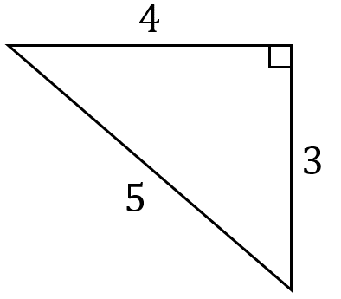
- Here is a triangle. Prove that it is right-angled.
$a^{2}+b^{2}=$…… + ……  $=$…… + ……  $=$…… | $h^{2}=$ ……  $=$ ……
…………………………………………………
…………………………………………………
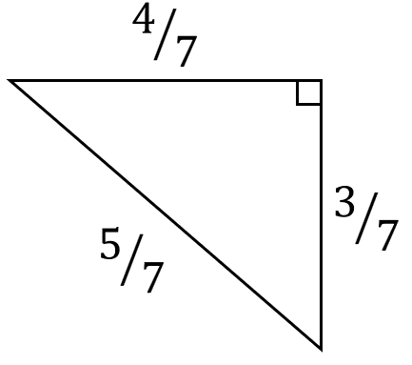
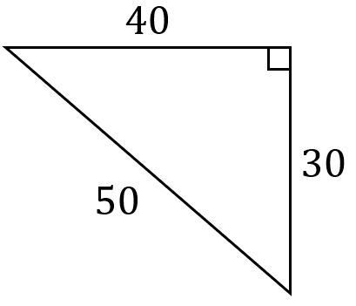
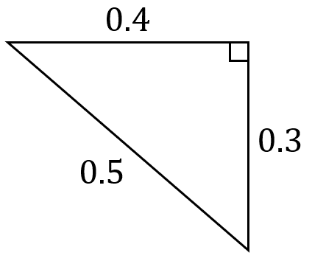
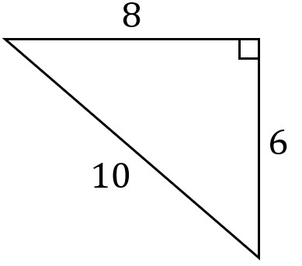
Here are some more right-angled triangles.

Compare the side lengths of these triangles with the triangle above.
What’s the relationship between the sides of these triangles?

Each side has been multiplied or divided by the same factor.
Complete the sentence:
A right-angled triangle will stay right-angled as long as you ……………… or ……………… each side by the same number.
Multiply, divide
Draw three more right-angled triangles that are based on the 3, 4, 5 triangle.

- Pythagoras developed a formula for finding Pythagorean triads ($a$, $b$, $c$).
If one number in the triad is $a$, the formulas for the other 2 numbers are:
$$b=\frac{1}{2}\left(a^{2}-1\right) and c=\frac{1}{2}\left(a^{2}+1\right)$$
  - If $a=5$, use the formulas to find the values of $b$ and $c$.

$$5, 12, 13$$
  - If $a=7$, use the formulas to find the values of $b$ and $c$.

$$7, 24, 25$$

- $(8, 15, n)$ satisfies Pythagoras’ theorem.
  - Find two possible value(s) of $n$.
If $n$ is the largest number:
$$8^{2}+{15}^{2}=n^{2}$$
$$n=\sqrt{8^{2}+{15}^{2}}=17$$
If $n$ is one of the shorter sides
$$8^{2}+n^{2}={15}^{2}$$
$$n=\sqrt{{15}^{2}-8^{2}}$$
$$=12.68857754…$$
  - Explain why 17 is the only answer if the question asks for a Pythagorean triad.

The numbers of a Pythagorean triad must be whole numbers
- $(18, 30, n)$ is a Pythagorean triad. Find the value(s) of $n$.

24 is the only answer.
- $\left(13,85, n\right)$ is a Pythagorean triad. Find the value(s) of $n$.

84 is the only answer.

Calculating the Length of the Hypotenuse

- Review
- Write Pythagoras’ theorem from a right-angled triangle
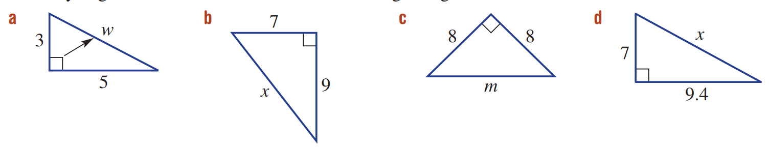

- Square root numbers
- $\sqrt{16}$ | - $\sqrt{18}$ | - $\sqrt{225}$

- Solve equations with square roots
- $x^{2}=9+49$ | - $x^{2}=3^{2}+5^{2}$ | - $x^{2}={6.2}^{2}+4^{2}$

- Identify whether to leave a root in exact form
Square roots that do not make a nice terminating decimal should be left as a root.
This is called leaving in exact form or surd form.
$\sqrt{225}$ should be simplified to 15. Leave $\sqrt{146}≈12.08304597…$ as is.

Decide whether these roots can be written as a whole number or should be left as a root.
- $\sqrt{9}$ | - $\sqrt{11}$ | - $\sqrt{121}$ | - $\sqrt{20}$
- $\sqrt{144}$ | - $\sqrt{145}$ | - $\sqrt{100}$ | - $\sqrt{99}$

- Calculating the Length of the Hypotenuse
If you have a right-angled triangle and the lengths of two sides,
then you can use Pythagoras’ theorem to calculate the length of the remaining side.
- Write the formula $a^{2}+b^{2}=h^{2}$
- Substitute given values.
- Solve for the unknown by applying inverse operations to both sides.

- Example Calculate the length of the hypotenuse
Calculate the value of $x$  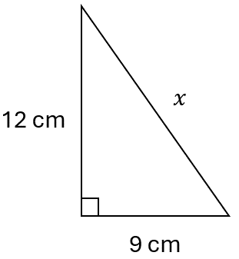  1. $a^{2}+b^{2}=h^{2}$2. $9^{2}+{12}^{2}=x^{2}$3. $225=x^{2}$  $\sqrt{225}=x$ $15=x$ | Why can we use Pythagoras’ Theorem?  We can use Pythagoras’ Theorem when there is a ………… - ………… triangle.  Which operation did we do to go from  $h^{2}=225$ to $h=\sqrt{225}?$  We ………… ……………… both sides.

- Guided Practice
Find the length of the hypotenuse. Round your answer to 2 d.p.
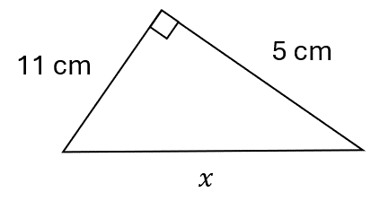  1. $a^{2}+b^{2}=h^{2}$  2. ……² $+$ ……² $=x^{2}$  3. …… $+$ …… $=x^{2}$  …… $=x^{2}$  $\sqrt{ }=x$  …… $=x$  $x=12.08$ cm | 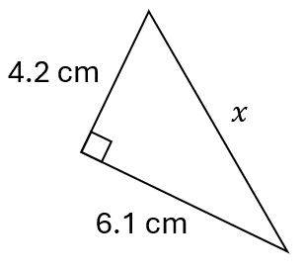  $x=7.41$ cm

Foundation
- Find the length of the hypotenuse for these triangles.
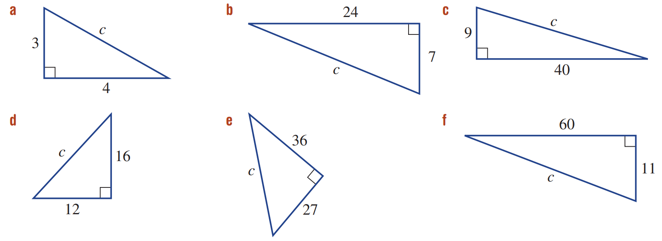  $h^{2}=a^{2}+b^{2}$  $y^{2}=$ ……² $+$ ……²  $y^{2}=$ …… $+$ ……  $y^{2}=$ ……  $y=$  $=$ ……  25 | $h^{2}=a^{2}+b^{2}$  $y^{2}=$ ……² $+$ ……²  $y^{2}=$ …… $+$ ……  $y^{2}=$ ……  $y=$  $=$ ……  41 | $h^{2}=a^{2}+b^{2}$  $y^{2}=$ ……² $+$ ……²  $y^{2}=$ …… $+$ ……  $y^{2}=$ ……  $y=$  $=$ ……  20

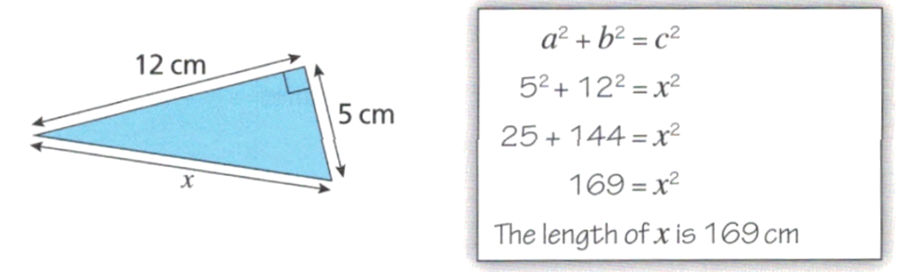
- Jayden is finding the length of the hypotenuse in this right-angled triangle.
His working out is shown.

What mistake has he made?

He forgot to square root
- The foot of a ladder is placed 1.2 m from a vertical wall. If the ladder reaches 7 m up the wall, what is the length of the ladder? Answer in metres to 2 decimal places.
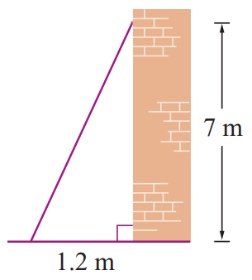

7.10 m

Development
- Find the length of the hypotenuse for these triangles. Leave your answer in exact form.
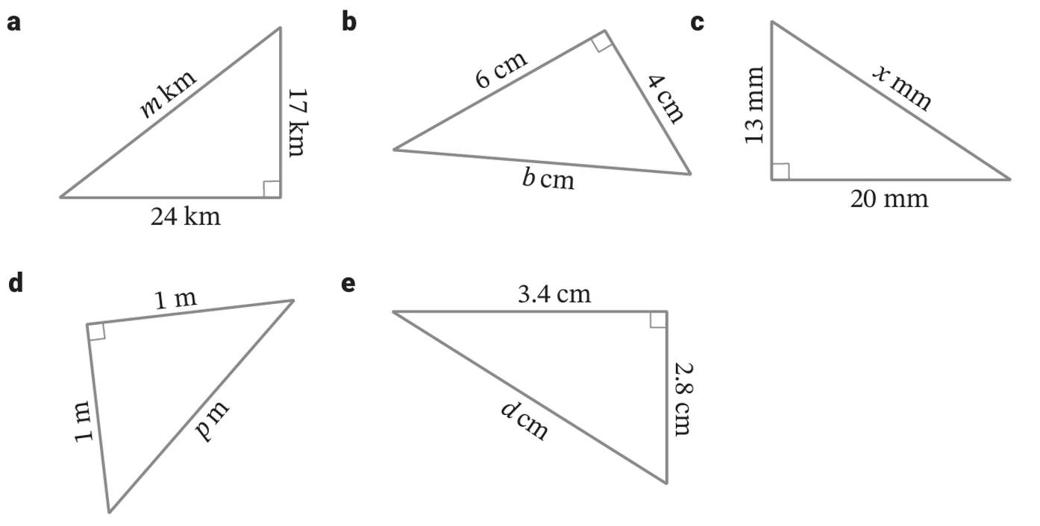  $h^{2}=a^{2}+b^{2}$  …²$=$ ……² $+$ ……²  …²$=$ …… $+$ ……  …²$=$ ……  …$=$  $\sqrt{865}$ km | $\sqrt{52}$ cm | $\sqrt{569}$ mm
$\sqrt{2}$ m | $\sqrt{19.4}$ cm | 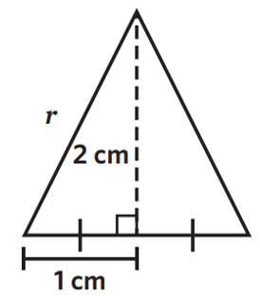  $\sqrt{5}$ cm

- A gate is 2.3 m wide with a height of 1.4 m.
Calculate the length of the diagonal of the gate correct to 1 decimal place.
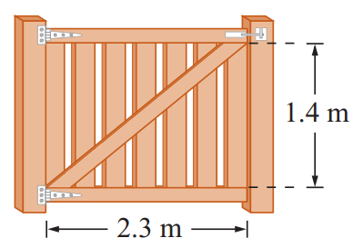

2.7 m

Calculating the Length of a Shorter Side

- Review
- Write Pythagoras’ theorem from a right-angled triangle
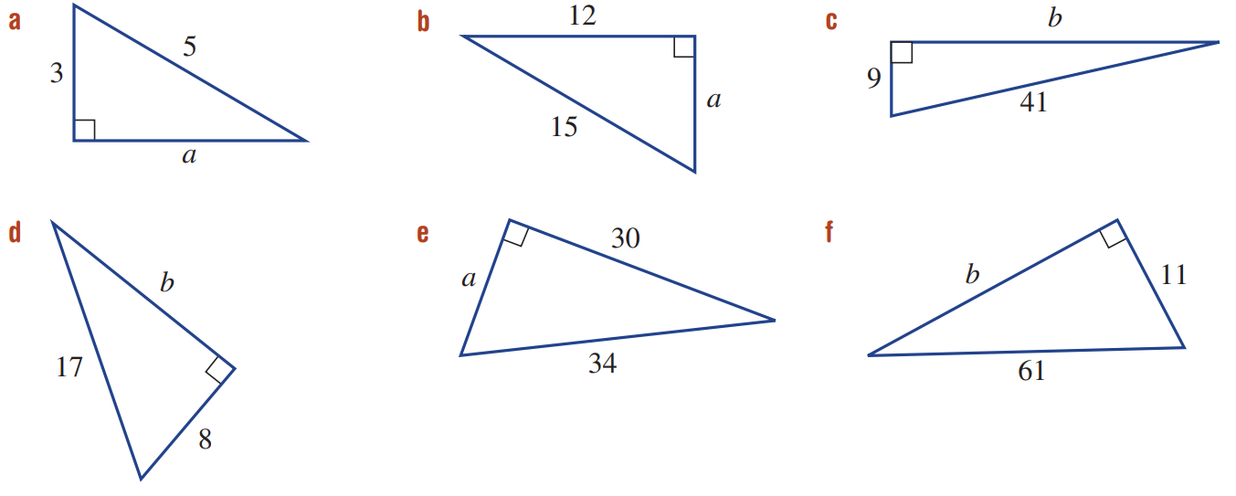

- Solve equations with square roots
- $x^{2}+9=45$ | - $x^{2}+3^{2}=5^{2}$ | - $x^{2}+7^{2}=8^{2}$

- Use formulas
- $a+b=c$  Solve for $a$ if  $b=22$ and $c=59$ | - $f^{2}+e=g$  Solve for $f$ if  $e=15$ and $g=23$ | - $x^{2}+y^{2}=z^{2}$  Solve for $y$ if  $x=3$ and $z=5$

- Calculating the Length of a Shorter Side
If you have a right-angled triangle and the lengths of two sides,
then you can use Pythagoras’ theorem to calculate the length of the remaining side.
- Write the formula $a^{2}+b^{2}=h^{2}$
- Substitute given values.
- Solve for the unknown by applying inverse operations to both sides.

- Example Calculate the length of the shorter side
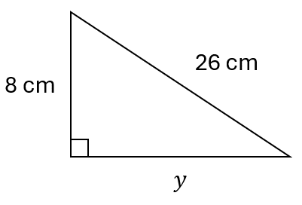  Calculate the value of $y$.  1. $a^{2}+b^{2}=h^{2}$2. $y^{2}+8^{2}={26}^{2}$3. $-8^{2}=-8^{2}$ $y^{2}=612$ $y=\sqrt{612}$ | What operation did we do to both sides to go from $y^{2}+8^{2}={26}^{2}$ to $y^{2}=612$?  We ……………… $8^{2}$ from both sides.  What operation did we do to both sides to go from $h^{2}=612$ to $h=\sqrt{612}$?  We ………… ………… both sides.

- Guided Practice
Find the length of the hypotenuse. Round your answer to 2 d.p.
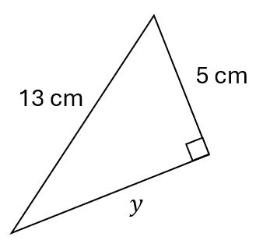  $a^{2}+b^{2}=h^{2}$  $y^{2}$ $+$ ……² $=$……²  $y^{2}=$ ………  $y=\sqrt{ }$  $≈$ ………  $y=12$ cm | 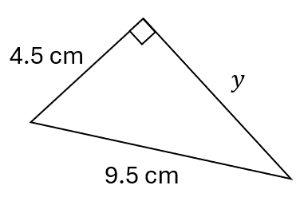  $y=8.37$ cm

Foundation
- Calculate the side lengths of these triangles.
$a^{2}+b^{2}=h^{2}$  $a^{2}$ $+$ ……² $=$……²  $a^{2}$ $=$ ………  $a=\sqrt{ }$  $a$ $=$ …………  9 | $a^{2}+b^{2}=h^{2}$  ……² $+$ ……² $=$……²  $b^{2}$ $=$ ………  $b=\sqrt{ }$  $b$ $=$ …………  60 | $a^{2}+b^{2}=h^{2}$  40

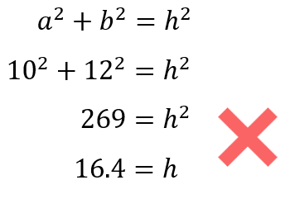
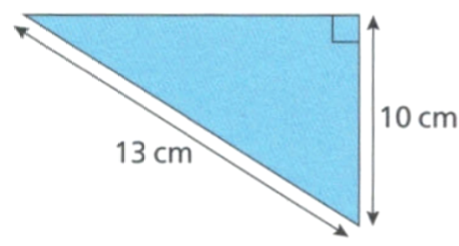
- Jayden is finding the missing length in this right-angled triangle.
His working out is shown.

What mistake has he made?

He substituted incorrectly. The hypotenuse is 13.
- Find the length of the hypotenuse for these triangles. Leave your answer in exact form.
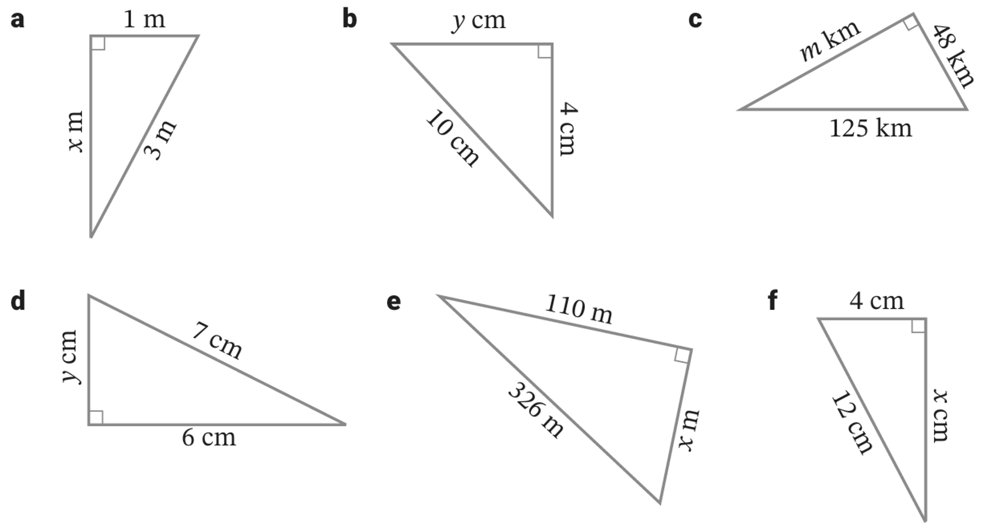  $a^{2}+b^{2}=h^{2}$  ……² $+$ ……² $=$……²  $x^{2}$ $=$ ………  $x=\sqrt{ }$  $x$ $=$ …………  $\sqrt{8}$ m | $\sqrt{84}$ cm | $\sqrt{13321}$ km

Development
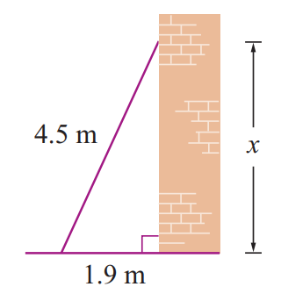
- A ladder 4.5 m in length is placed 1.9 m from the base of a vertical wall.
How far does the ladder reach up the wall to the nearest centimetre?

408 cm
- A kite is flying with 42 m of string which is anchored to the ground.
The horizontal distance from where the string is anchored is 27 m.
Find the height of the kite above the ground to the nearest centimetre.
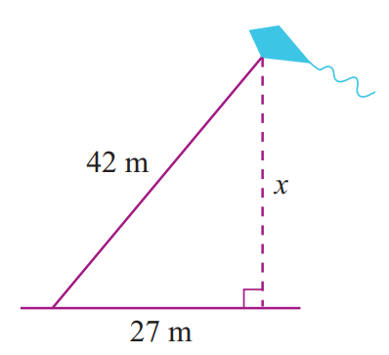

3217 cm
- Oliver holds the end of the string of a kite 1.2 m above the ground.
The string is 30 m long and the horizontal distance to the kite is 18 m.
Find the height of the kite above the ground.
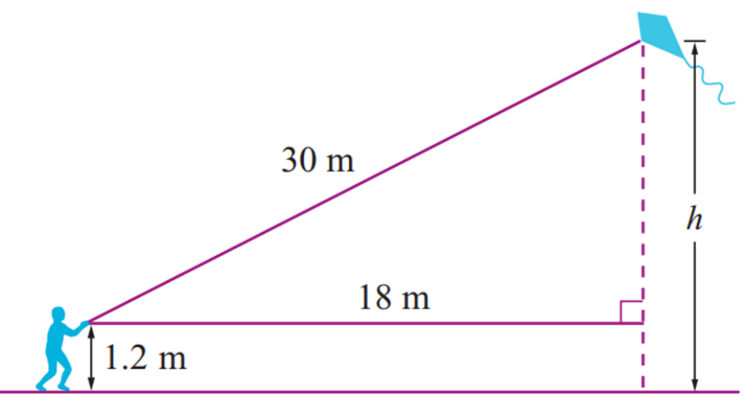

25.2 m

Choosing an Appropriate Strategy

- Shortcuts for Pythagoras’ Theorem
These are two formulas for using Pythagoras’ theorem quickly:

Finding the hypotenuse:  $$h=\sqrt{a^{2}+b^{2}}$$ | Finding a shorter side:  $$a=\sqrt{h^{2}-b^{2}}$$

- Identify the formula to use to find the unknown side
Identify which formula to use to find the unknown side.
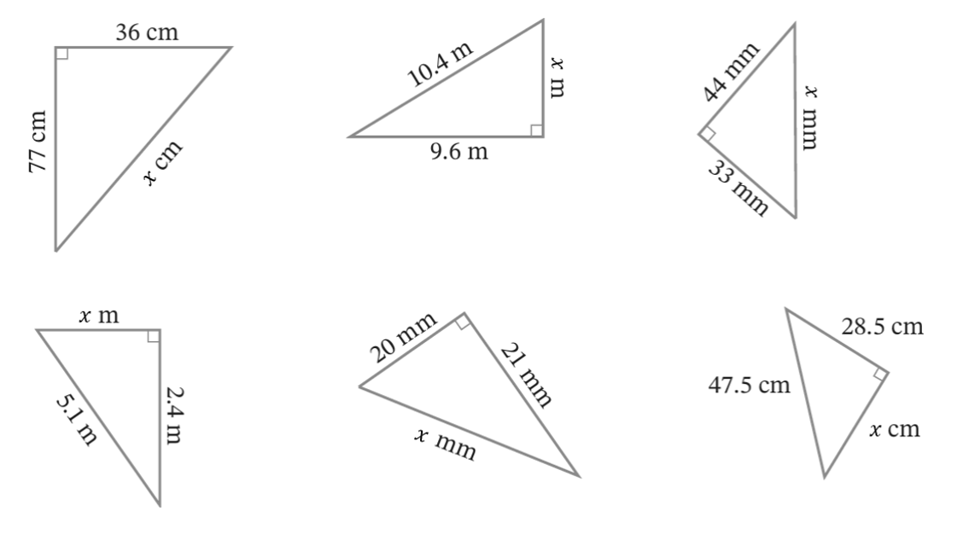  - $h=\sqrt{a^{2}+b^{2}}$  - $a=\sqrt{h^{2}-b^{2}}$ | - $h=\sqrt{a^{2}+b^{2}}$  - $a=\sqrt{h^{2}-b^{2}}$ | - $h=\sqrt{a^{2}+b^{2}}$  - $a=\sqrt{h^{2}-b^{2}}$
- $h=\sqrt{a^{2}+b^{2}}$  - $a=\sqrt{h^{2}-b^{2}}$ | - $h=\sqrt{a^{2}+b^{2}}$  - $a=\sqrt{h^{2}-b^{2}}$ | - $h=\sqrt{a^{2}+b^{2}}$  - $a=\sqrt{h^{2}-b^{2}}$

Foundation
- For the following questions, find the unknown side using the shortcut.
Round any answers to 1 d.p. where required.

$$x=\sqrt{{77}^{2}+{36}^{2}}$$  $=$ ……………  $85$ cm | $$x=\sqrt{{10.4}^{2}-{9.6}^{2}}$$  $=$ ………………  $4$ m | $55$ mm
$4.5$ m | $29$ mm | $38$ cm
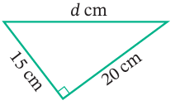  $25$ cm | 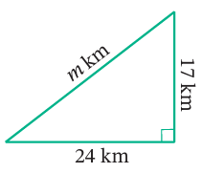  $29.4$ km | 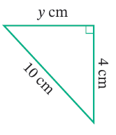  $9.2$ cm
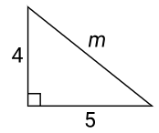  $$6.4$$ | 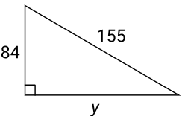  $130.3$ | 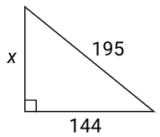  131.5

Development
- Calculate the missing side in each of these triangles. Leave your answer in exact form.
10 cm | 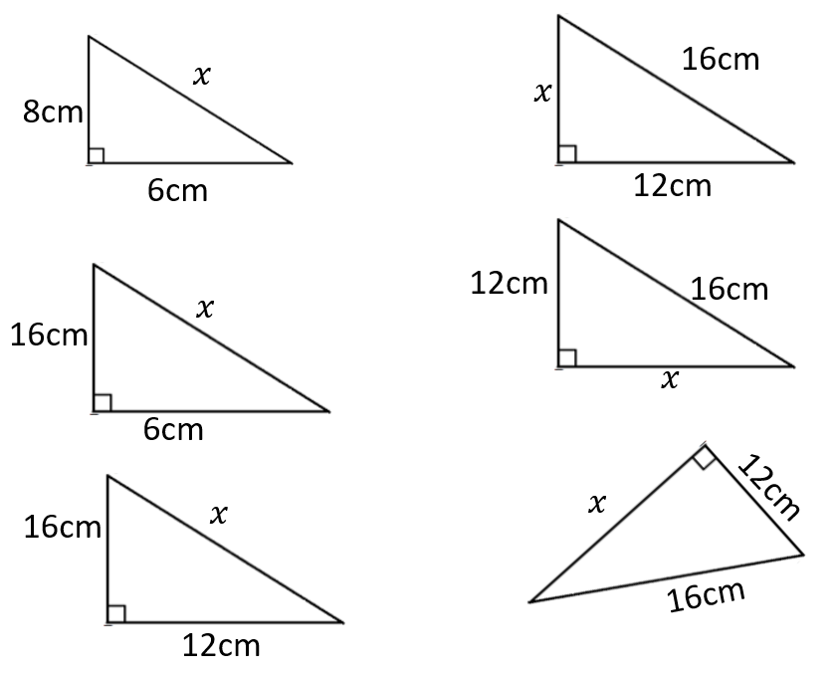  $\sqrt{292}$ cm | 20 cm
$\sqrt{112}$ cm | $\sqrt{112}$ cm | $\sqrt{112}$ cm
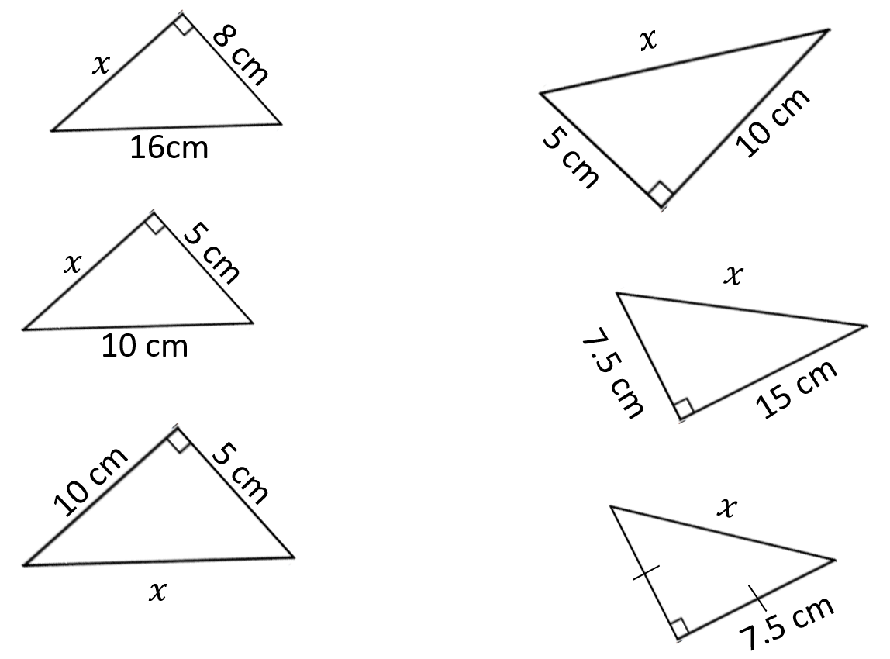  $\sqrt{192}$ cm | $\sqrt{75}$ cm | $\sqrt{125}$ cm
$\sqrt{125}$ cm | $\sqrt{281.25}$ cm | $\sqrt{112.5}$ cm

Solving Problems using Right-Angled Triangles

- Solving Problems with Right-Angled Triangles
If a question involves a right-angled triangle and the lengths of two sides is given,
then we can use Pythagoras’ theorem to find the third side.
- Identify the right-angled triangle.
- Solve for the unknown side using the appropriate formula.
Finding the hypotenuse:  $$h=\sqrt{a^{2}+b^{2}}$$ | Finding a shorter side:  $$a=\sqrt{h^{2}-b^{2}}$$

- Example Solve problems involving Pythagoras’ Theorem
Find the value of the pronumeral, round your answer to 2 d.p.
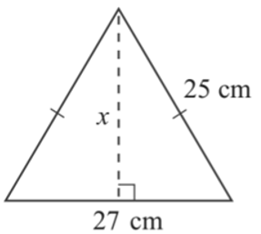
1.
13.5

2.
$$x=\sqrt{{25}^{2}-{13.5}^{2}}$$
$=21.04$ cm

- Guided Practice
Find the value of the pronumeral. Round your answer to 2 d.p.
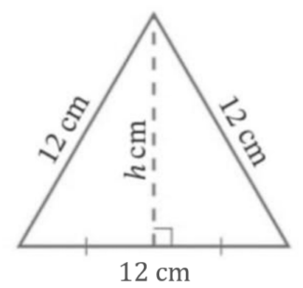  10.39 cm | 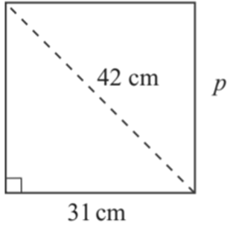  28.34 cm
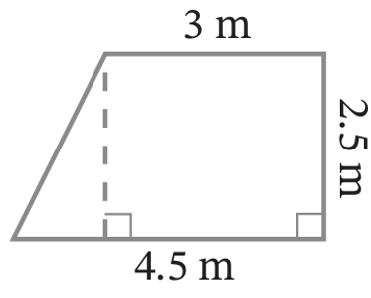  1.5  2.5  $$x$$  2.92 m | 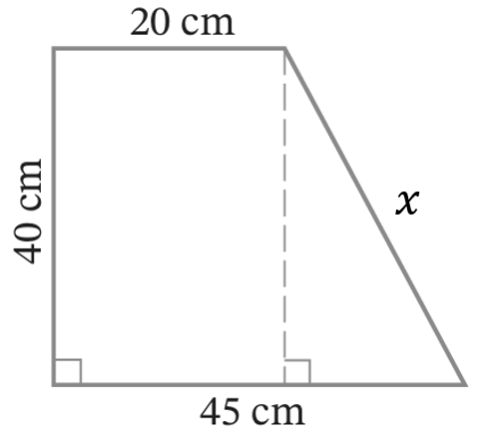  47.17 cm

Foundation
- Calculate the missing side in these triangles. Round your answer to two decimal places.
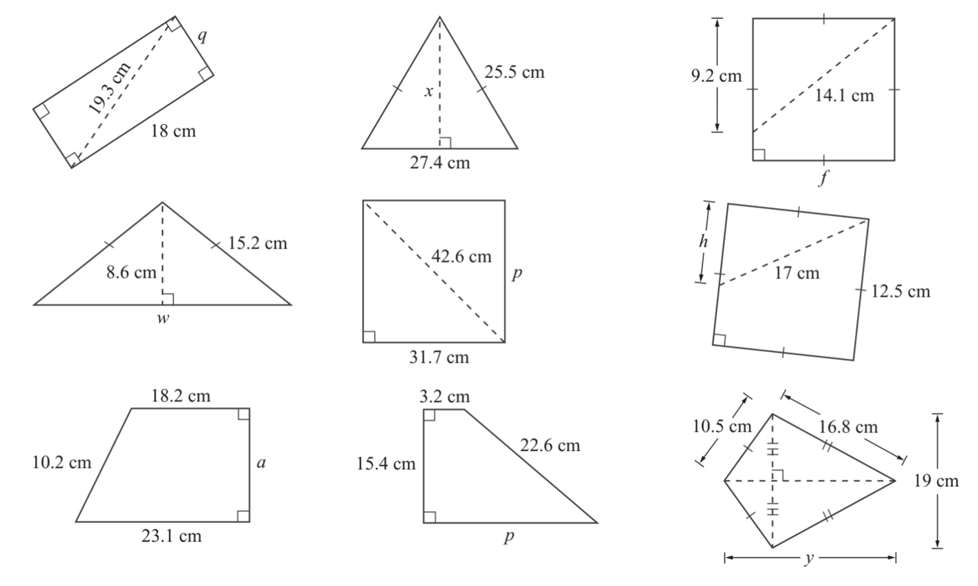  6.96 cm | 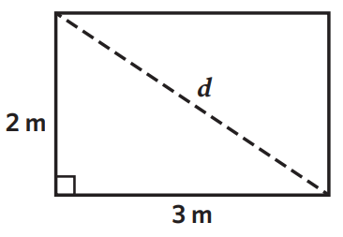  3.61 m | 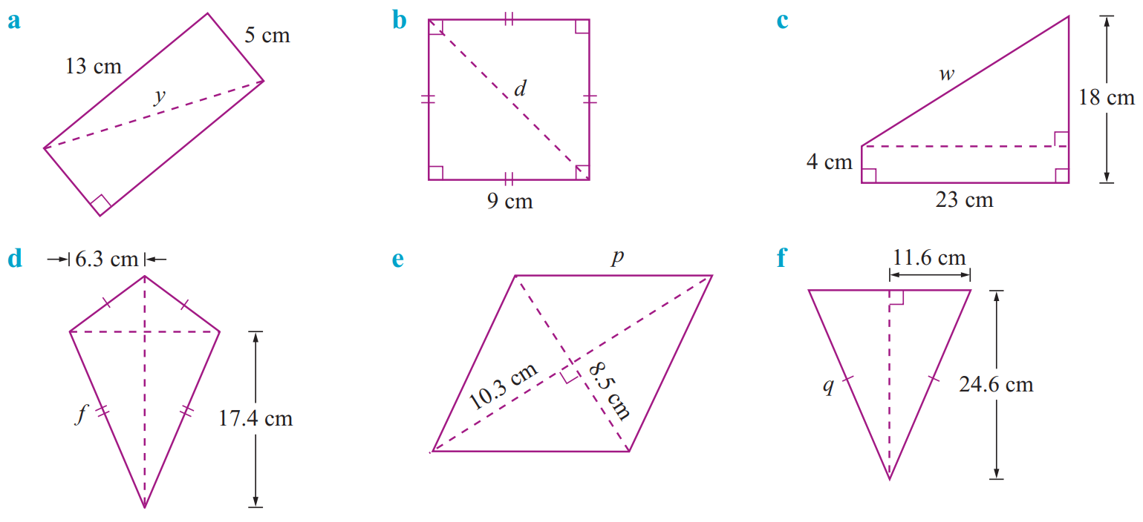  27.20 cm
12.73 cm | 11.52 cm | 13.35 cm
10.69 cm | 26.93 cm | 25.07 cm
8.95 cm | 19.74 cm | 18.33 cm
- Solve for the unknown value.
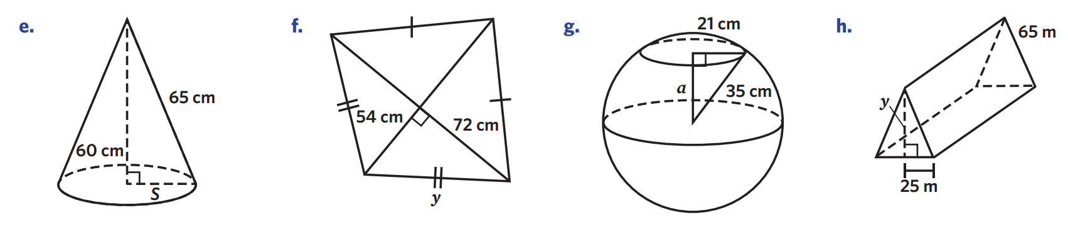  25 cm | 90 cm
28 cm | 60 m

- Find the height of these triangles. Round your answer to 1 d.p.
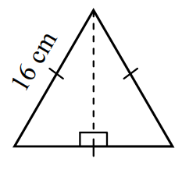  13.9 cm | 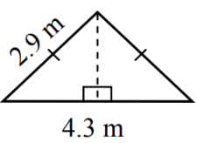  1.9 m | 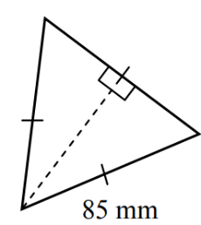  73.6 mm
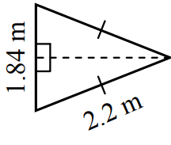  2.0 m | 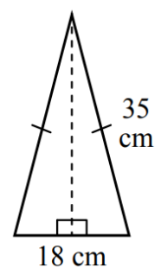  33.8 cm | 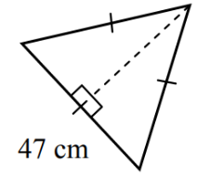  40.7 cm

Development
- A right-angled triangle has one shorter side 5 m long and its longest side is exactly $\sqrt{61}$ m long. How long is the other side?

6 m
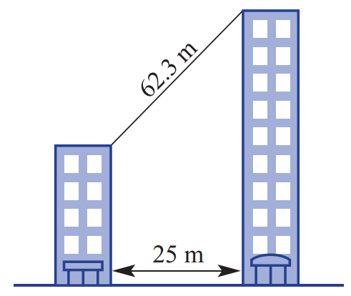
- Calculate the difference in height between these two buildings.
Round your answer to 1 d.p.

57.1 m
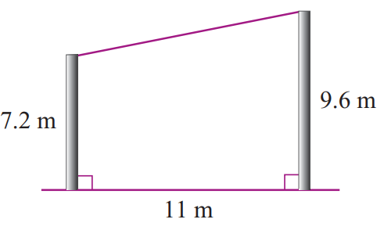
- Two posts are 7.2 m tall and 9.6 m tall and 11 m apart on level ground.
Calculate the length of string required to stretch from the top of one post to the top of the other.
Round your answer to 1 d.p.

11.3 m
- A 20, 99 and $x$ form a Pythagorean triad, where $x$ is the largest number. Find the value of $x$.

101

- This shape is made up of two right-angled triangles. Find the perimeter of this shape to 2.d.p.
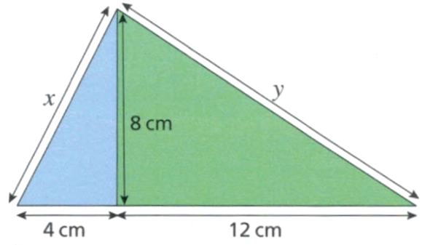

39.37 cm

- You are constructing a triangle with side lengths 18 cm and 22 cm.
What length do you need to make the third side so that the triangle is right-angled?
Note: there are two possible answers. Round your answers to 2 decimal places.

Possibility 1: 18 and 22 are the shorter sides.
Third side is $\sqrt{{18}^{2}+{22}^{2}}=28.43$ cm
Possibility 2: 22 is the hypotenuse
$\sqrt{{22}^{2}-{18}^{2}}=12.65$ cm
- Find the side length of these triangles. Round your answer to 1 d.p.
40.2 cm | 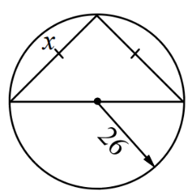  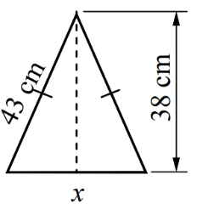  36.8 | 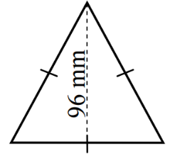  $$x$$  $$2x$$  $$x$$  $55.4$ mm

Mastery
- Find the perimeter of these shapes, correct to two decimal places.
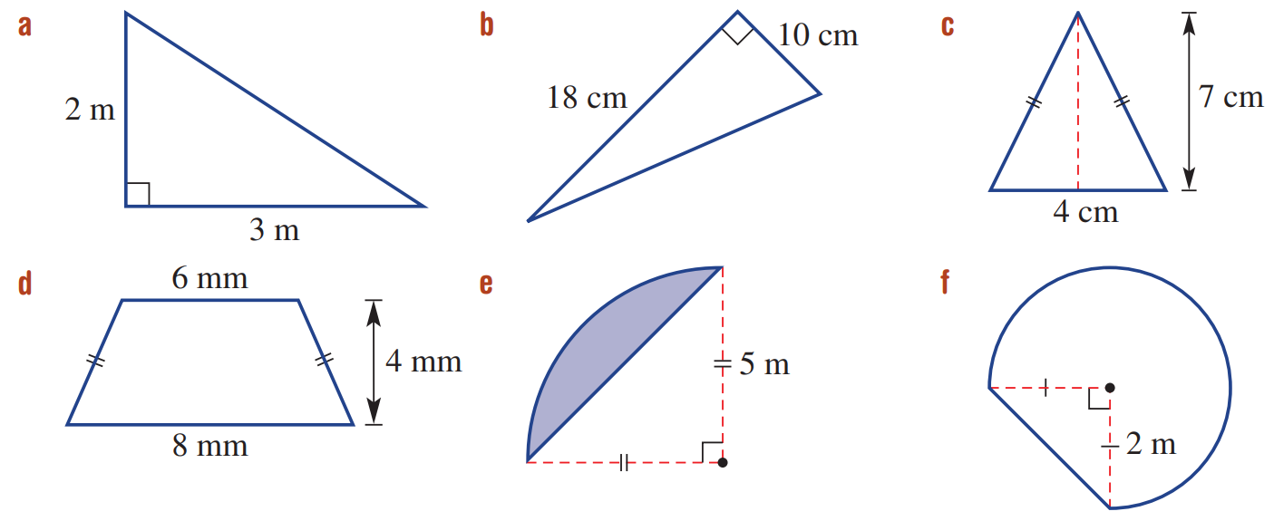  48.59 cm | 22.25 mm | - Arc-length formula  $l=\frac{θ}{360}×2πr$  12.25 m
- The diagonal of a rectangle is 10 cm long. The rectangle is twice as long as it is wide.
What are the dimensions of the rectangle? Round your answers to 2 decimal places

Let $x$ be width.
$$x^{2}+{\left(2x\right)}^{2}={10}^{2}$$
$$5x^{2}=100$$
$$x^{2}=20$$
$$x=\sqrt{20}$$
So, the rectangle is $\sqrt{20}$ cm by $2\sqrt{20}$ cm; 4.47 cm by 8.94 cm

  - Find the perpendicular height of an equilateral triangle, side length 10 cm.
Answer in exact surd form.

$\sqrt{{10}^{2}-5^{2}}=\sqrt{75}$ cm
  - Find the perpendicular height of an equilateral triangle with side length $x$ cm.

$$\sqrt{x^{2}-{\left(\frac{x}{2}\right)}^{2}}=\sqrt{x^{2}-\frac{x^{2}}{4}}=\sqrt{\frac{3x^{2}}{4}}$$

Solving Multistep Problems with Right-Angled Triangles

- Solving Multistep Problems with Right-Angled Triangles
Sometimes you need to find another missing length before you can find the final answer.
- Only round your answer at the final step.
Finding the hypotenuse:  $$h=\sqrt{a^{2}+b^{2}}$$ | Finding a shorter side:  $$a=\sqrt{h^{2}-b^{2}}$$

- Example Solve multistep problems involving Pythagoras’ Theorem
Find the value of $y$, then find $x$.
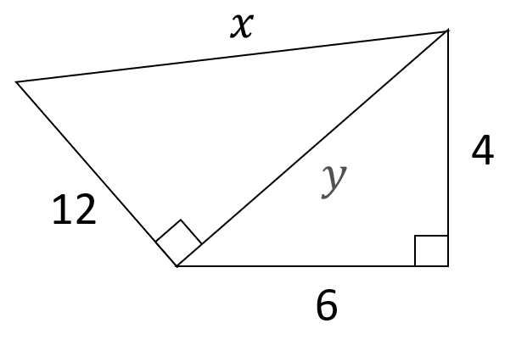
$y=\sqrt{4^{2}+6^{2}}=\sqrt{52}$

$x=\sqrt{{12}^{2}+y^{2}}$
$=\sqrt{{12}^{2}+{\left(\sqrt{52}\right)}^{2}}$
$=14$

- Guided Practice
Find the value of $y,$ then find $x$. Round your answer to 2 d.p.
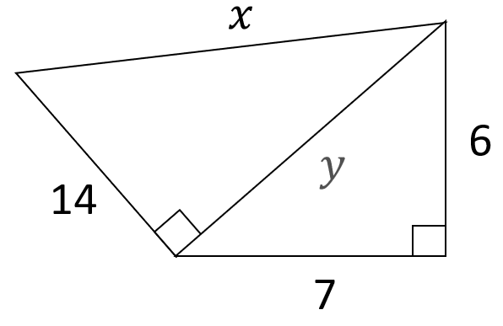  16.76 | 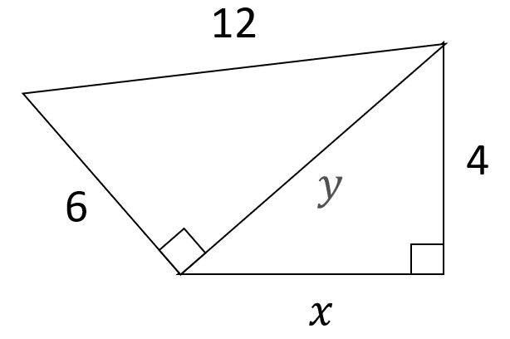  9.59
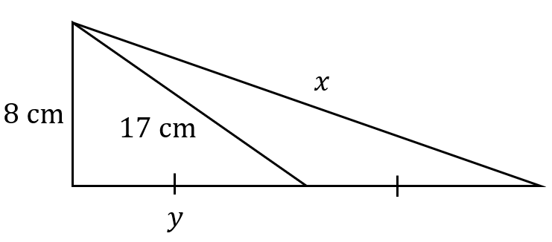  31.05 cm | 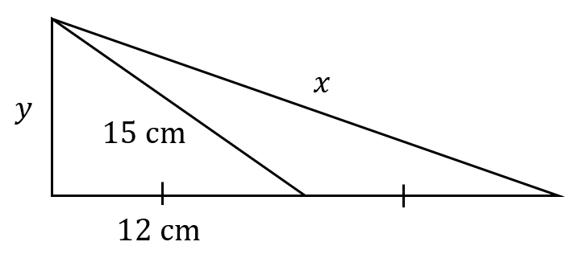  25.63 cm

Development
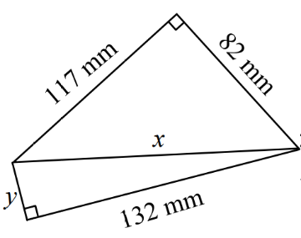
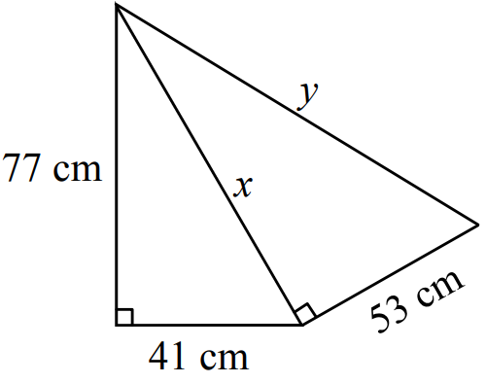
- Use Pythagoras’ Theorem twice to find $y$. Leave $x$ and the answer in surd form.
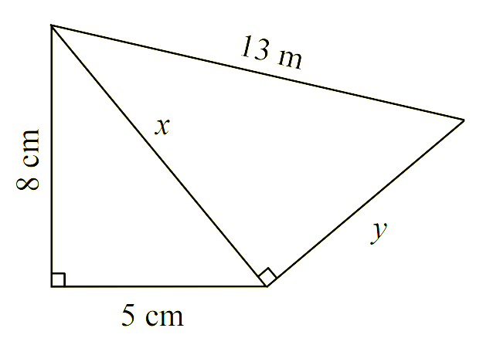  $x=\sqrt{5^{2}+8^{2}}=\sqrt{89}$  $y=\sqrt{{13}^{2}-{\left(\sqrt{89}\right)}^{2}}$  $y=$ ………  $y=\sqrt{80}$ m | $x=\sqrt{7610}, y=\sqrt{10419}$cm | $x=\sqrt{20413}, y=\sqrt{2989}$ mm

- Find the value of $x$. Answer in exact form.
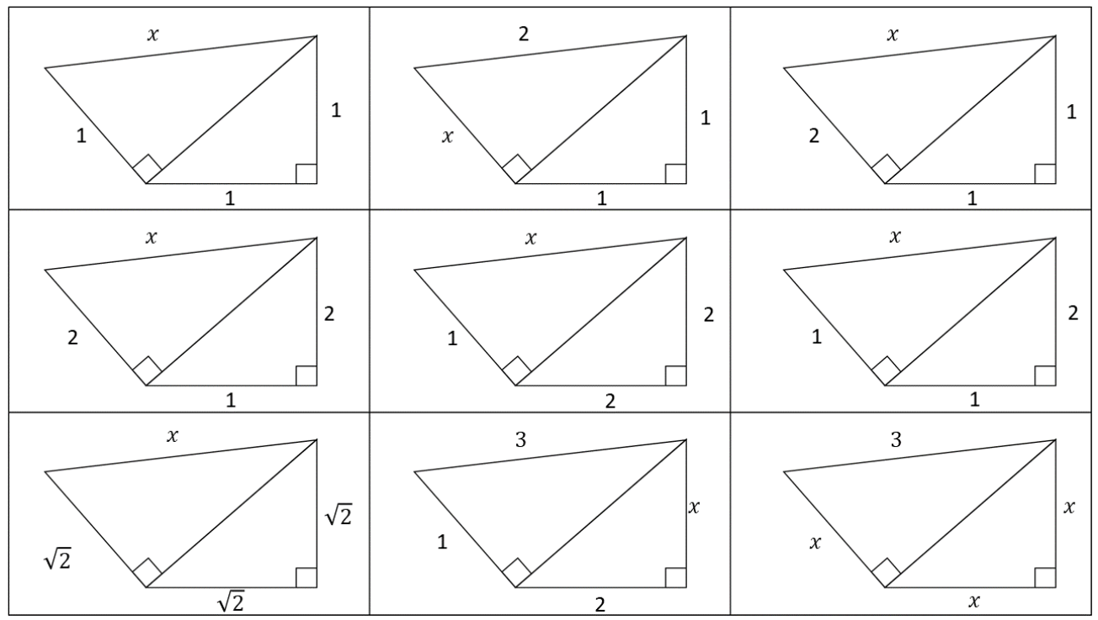  $$\sqrt{3}$$ | $$\sqrt{2}$$ | $$\sqrt{6}$$
3 | 3 | $$\sqrt{6}$$
$$\sqrt{6}$$ | 2 | $$\sqrt{3}$$
- Determine the unknown value, give your answer in exact form.
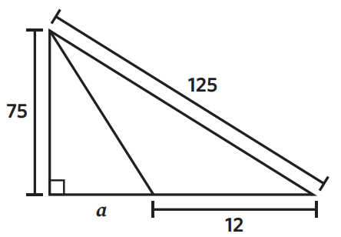  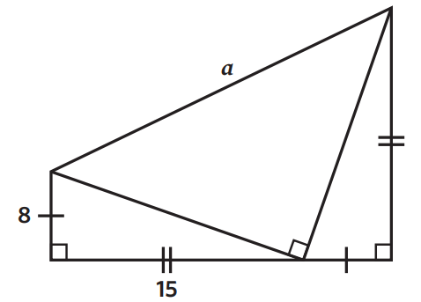  88 | $\sqrt{578}$ cm
- Find the missing sides, then find the perimeter. Round your answer to 1 d.p.
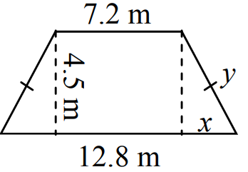  $$x=2.8, y=4.5, P=30.6$$ | 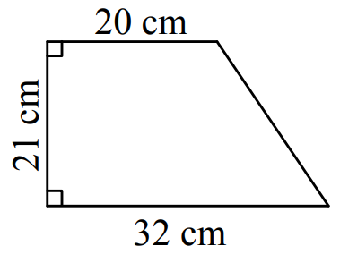  $P=97.2$cm
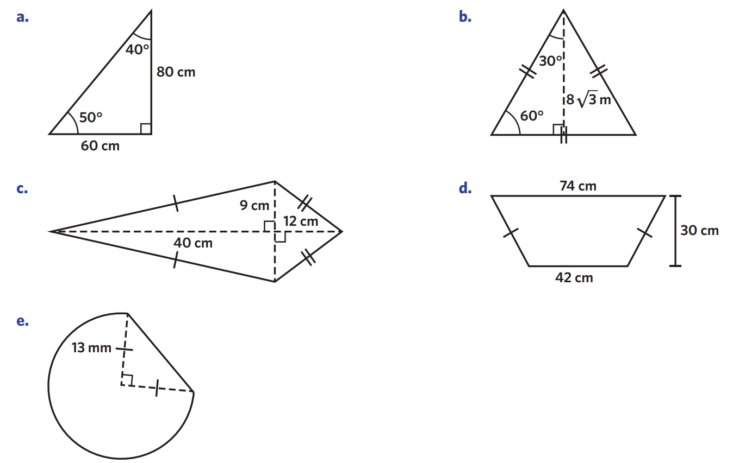  $P=112$ cm | $P=79.6$cm

- Find the value of $x$ in each question to 2 d.p.
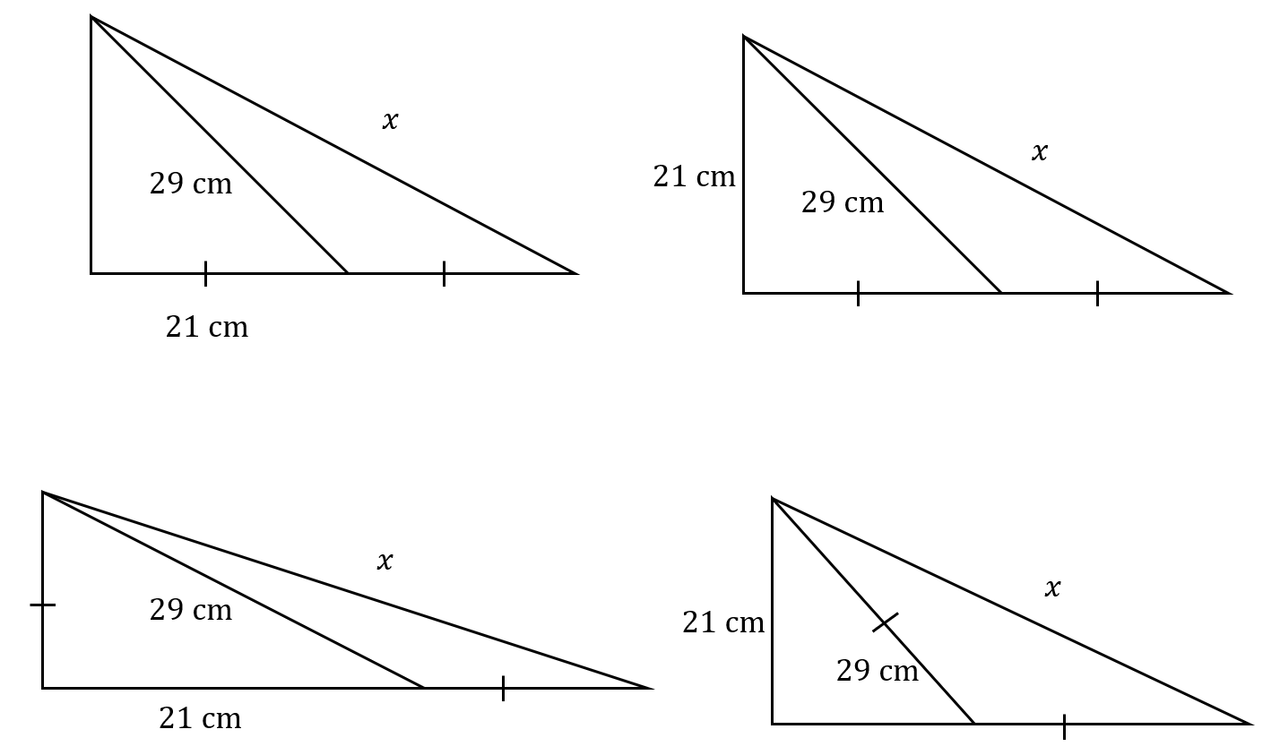  $46.52$cm | $45.18$cm
$46.62$cm | $53.51$cm
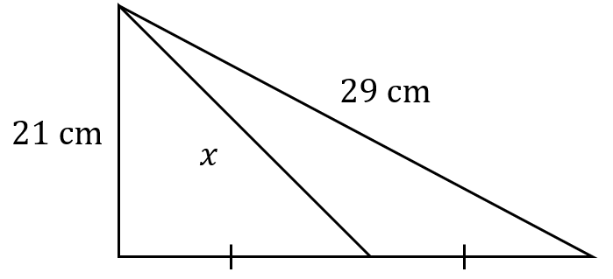  $23.26$cm | 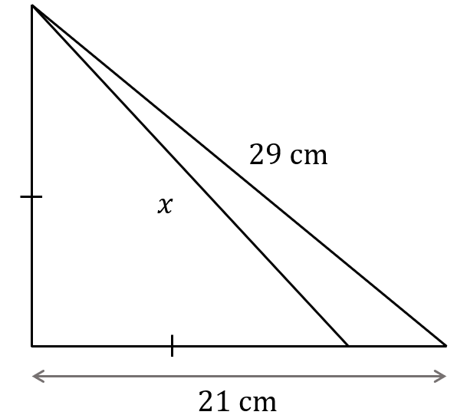  $28.29$cm

Mastery
- 2023 HSC Standard 2 Band 5
A cylindrical pipe with a radius of 12.5 cm is filled with water to a depth, $d$ cm, as shown.
The surface of the water has a width of 20 cm.
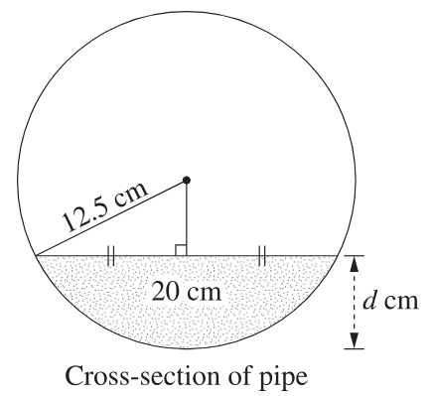
What is the depth of the water in the pipe?

Using Pythagoras, the vertical length of the triangle is $\sqrt{{12.5}^{2}-{10}^{2}}=7.5$ cm
So $d=12.5-7.5=5$ cm

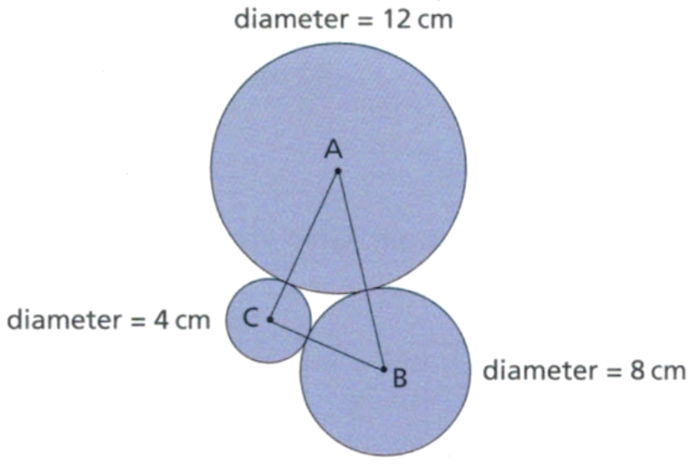
- The diagram shows three circles with centres A, B and C. The circles touch without overlapping. Show that triangle ABC is right-angled.

$$AB=6+4=10, BC=2+4=6, AC=2+6=8$$
$$AC^{2}+BC^{2}=100$$
$$AB^{2}=100$$
Since the sides satisfy $a^{2}+b^{2}=c^{2}$, the triangle is right angled.
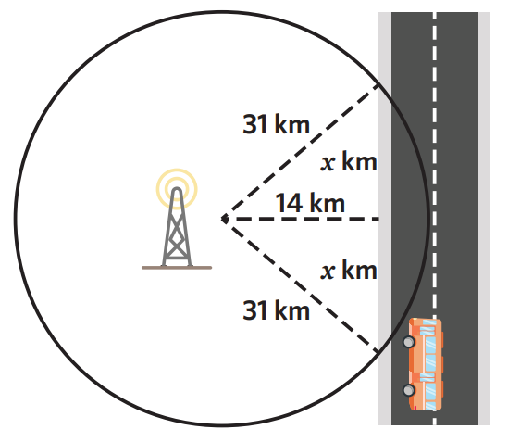
- A shuttle bus travels along an isolated road.
The bus passes a cell tower 14 km​ away from a road.
The cell tower provides signal in a 31 km radius.
For how ​many kilometres will people on the bus have signal? Round your answer to 2 d.p.

$x=\sqrt{{31}^{2}-{14}^{2}}=\sqrt{765}$ km
So, there will be signal for $2\sqrt{765}$ km = 55.32 km
- 2018 HSC Standard 2 Band 4
A shape consisting of a quadrant and a right-angled triangle is shown.
What is the perimeter, in exact form?
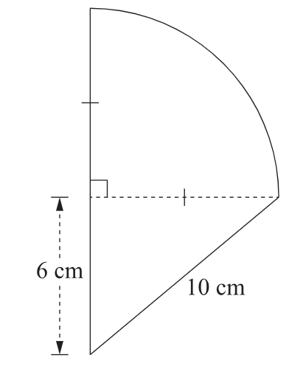

Radius of quadrant = $\sqrt{{10}^{2}-6^{2}}=8$ cm
Arc length = $\frac{3}{4}$ $×2π\left(8\right)=12π$
$$∴P=12π+8+6+10$$
$=12π+24$ cm

- Find the perimeter of these shapes. Answer to 1 d.p.
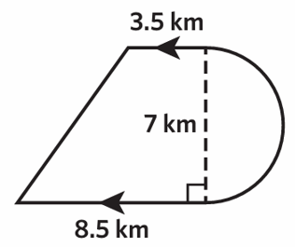  31.6 km | 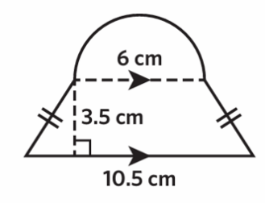  28.2 cm
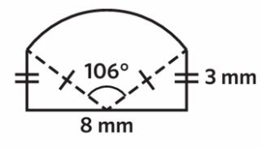  23.3 mm | 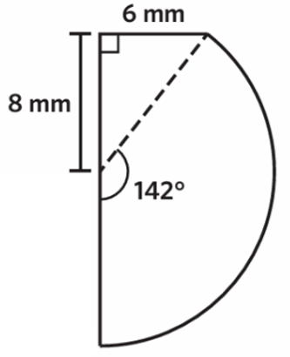  48.8 mm

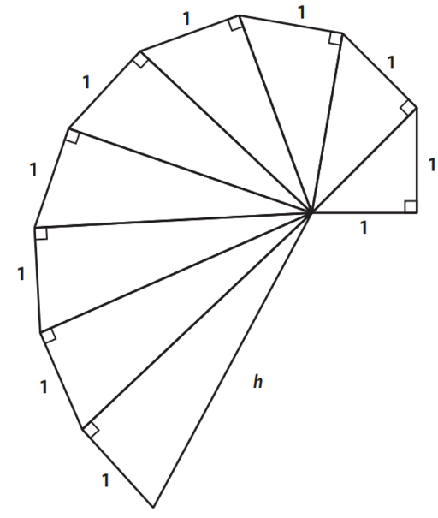
- Determine the value of $h$ in exact surd form.

$$h=\sqrt{10}$$
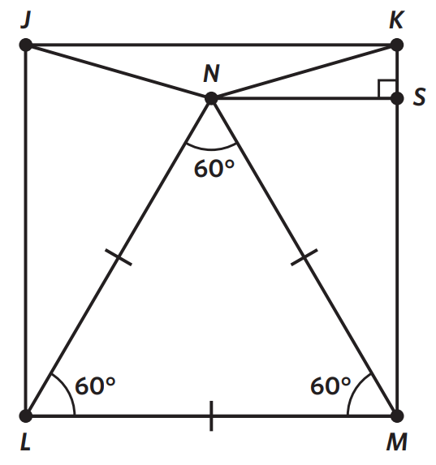
- JKML is a square. Determine the length of NK if the height of the triangle $ΔNML$ is 24 cm. Answer to two decimal places.

By splitting $ΔNML$ vertically down the middle, we create two right-angled triangles.
Let length of $NM=x$
$${\left(\frac{x}{2}\right)}^{2}+{24}^{2}=x^{2}$$
$$\frac{x^{2}}{4}+{24}^{2}=x^{2}$$
$${24}^{2}=\frac{3x^{2}}{4}$$
$$…$$
$x=\sqrt{768}$ cm
$$KS=KM-SM$$
$$=\sqrt{768}-24$$
$$NS=\frac{\sqrt{768}}{2}$$
$∴NK=\sqrt{{\left(\sqrt{768}-24\right)}^{2}+{\left(\frac{\sqrt{768}}{2}\right)}^{2}}=14.35$ cm

- A rectangle 5 m by 24 m is cut diagonally to make a right-angled triangle and a trapezium.
The two shapes are then rearranged to form a large right-angled triangle.
Determine the perimeter of the large right-angled triangle.

To make a cut that makes a right-angled triangle and trapezium you must start from a corner of the rectangle and go to an opposite side.
The diagonal of the trapezium and the diagonal of the small right-angled triangle must form the diagonal of the large right-angled triangle.
Since the diagonal of the trapezium and diagonal of the small right-angled triangle are the same, the only way for this to work is to make the cut connecting a vertex to a midpoint of the opposite side (two possibilities).
You can check your answer by seeing if the area of the new triangle matches the original rectangle.
60 cm or 101.26 cm
https://www.desmos.com/geometry/oi2zmkiaqn
https://www.desmos.com/geometry/dhogwgkg8g

